DC2 Phase 3: Progress Report

I’ve been focusing on implementation the past week, as I want to get that out of the way and make sure I can get things done before I start making design decisions and doing more literature search. Here’s what I have done since phase 2:

- Decided to use recharts rather than D3 because it’s easier to get started with, still very customizable, widely used, and it provides more defaults than D3, which means a good baseline to compare against.
- Got started with recharts, which requires setting up Node and React
- Transformed data into proper format for recharts using a Python script
- Created a simple web page with a slider and a default stacked bar chart (pictures below). Right now nothing changes dynamically with the slider except for the size. Adding and removing elements should be as simple as some if statements.
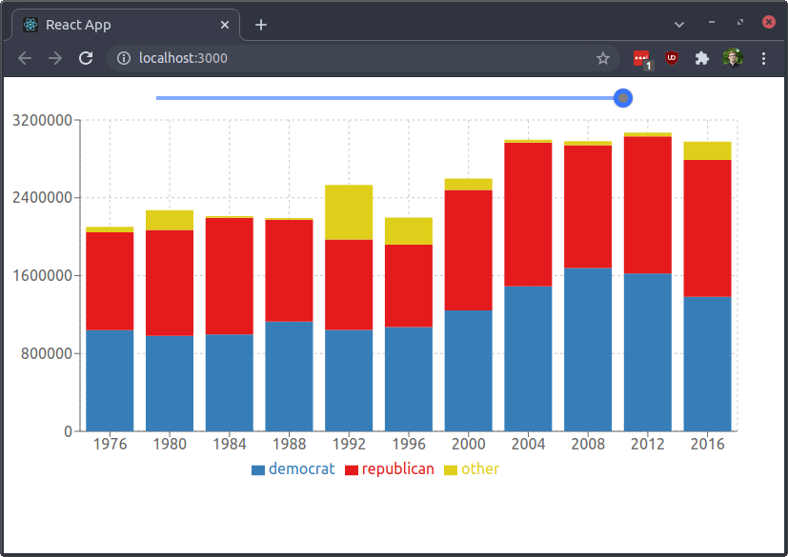
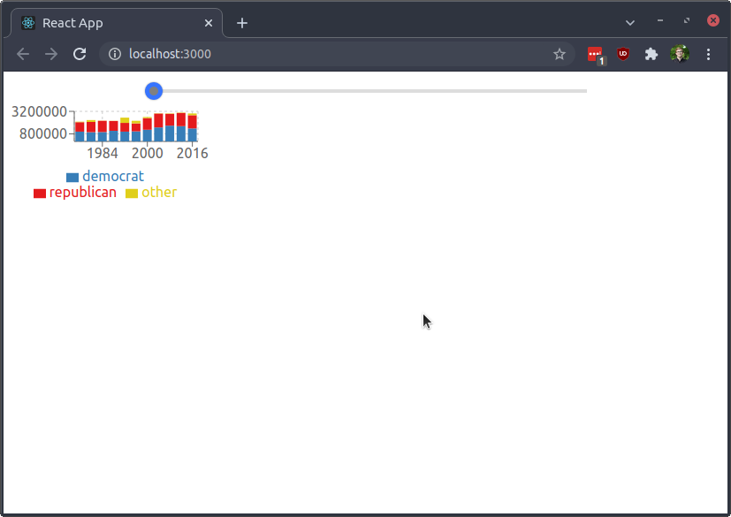
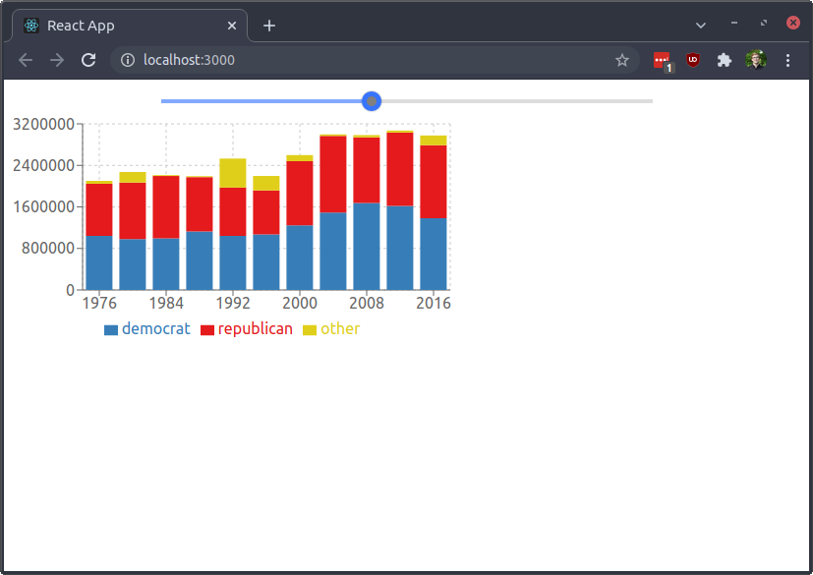
- You can see my current code on my GitHub repository

